1. Agenda:
   1. Returning Java Bean from some endpoint.
2. Graphical user interface, text, application

   Description automatically generated
3. Graphical user interface, text, application

   Description automatically generated
4. Text

   Description automatically generated
5. 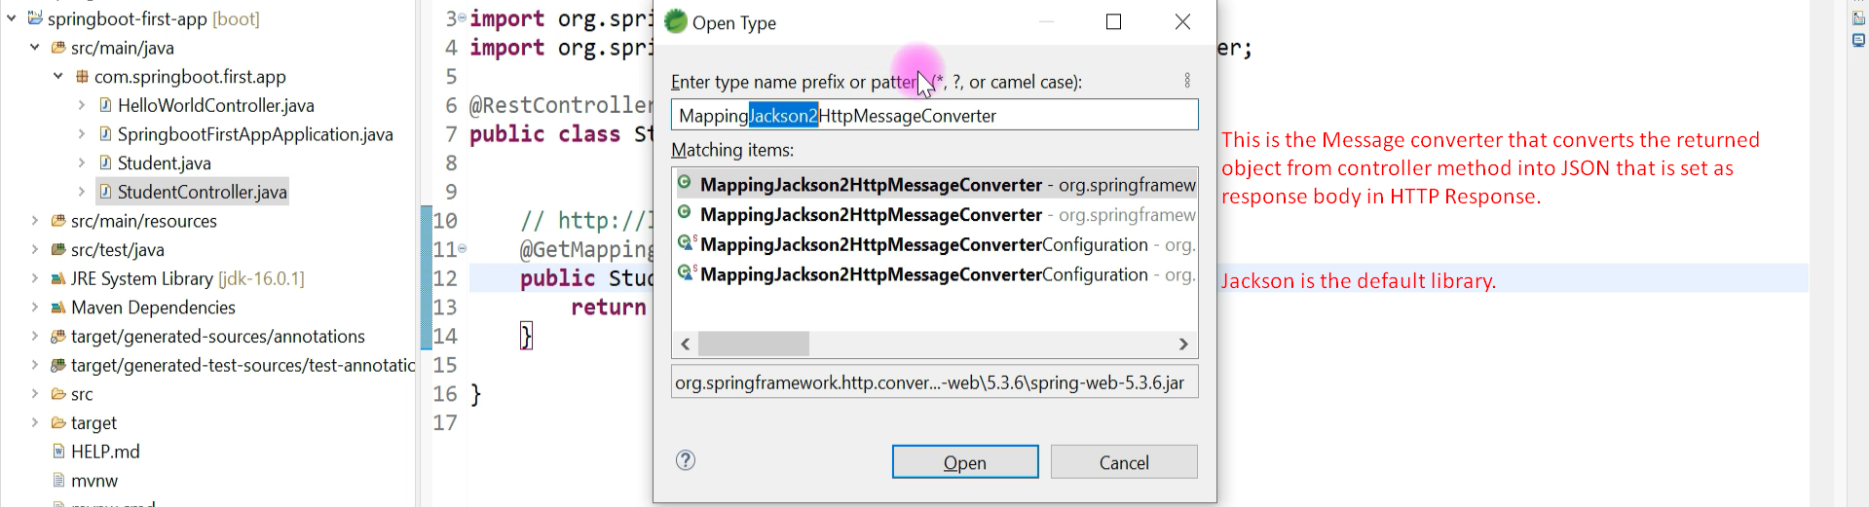
6. Graphical user interface, application

   Description automatically generated